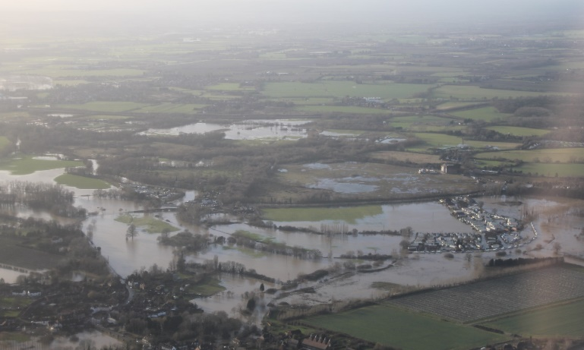
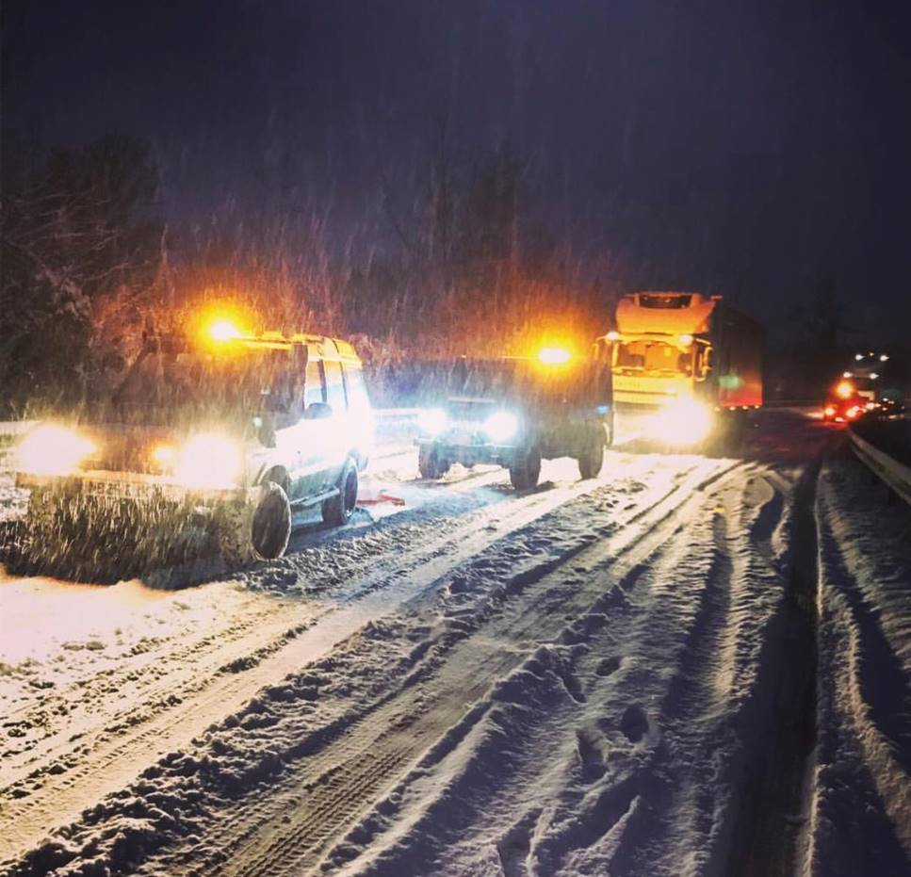
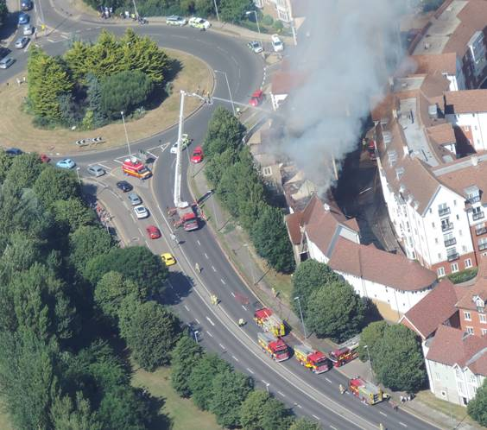
EMERGENCY
PLAN
HOUSEHOLD
Emergencies can affect the county with little or no notice.
Being prepared can help reduce the effects on your life and your loved ones; reduce the need for support from others and enable you to support the vulnerable in your community.
Disruption to essential services such as water, gas and electricity, regional and national travel and telecommunications are all ways an emergency can affect our everyday lives.
A crisis happens when we least expect it.
GO IN.
STAY IN.
TUNE IN.

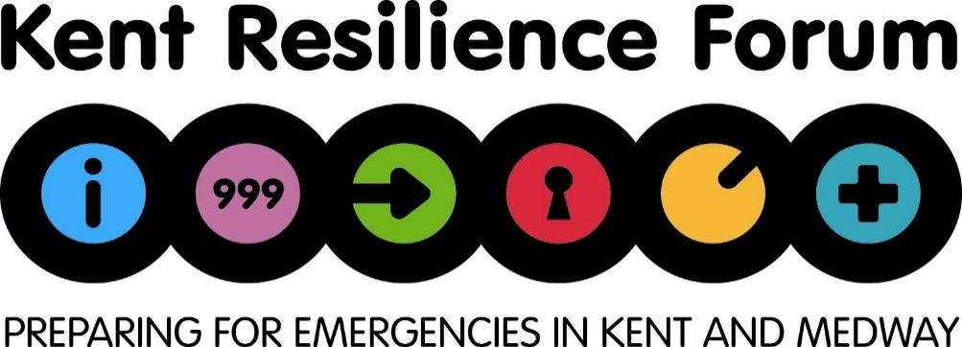

If you are not involved in an emergency but are close by or believe you may be in danger, in most cases the advice is:
GO IN.
STAY IN.
TUNE IN.

Station | Frequency | Website
BBC Kent | 96.7, 97.6, 104.2 FM | www.bbc.co.uk/bbckent
Heart | 97.0, 102.8, 103.1 FM | www.heart.co.uk/kent

Creating an emergency box/bag
Be prepared. Creating an emergency grab bag will help locate essential equipment quickly in an emergency. For more ideas on what to include in your grab bag visit “kentprepared.org.uk” and see the ‘Be prepared’ section. Some suggested items are:
 | Tick |  |  | Tick
Torch and spare batteries |  |  | First Aid Kit
Battery powered radio & spare batteries |  |  | List of useful contact numbers
Candles/matches |  |  | Toiletries/ Medication
Copy of this plan |  |  | Mobile phone & charger

In case you are unable to leave the house it is suggested you should have: | In case you are stuck in your car due to severe weather or congestion it is suggested you should have:

 | Tick |  |  | Tick
Bottled Water |  |  | Blankets
Ready to eat food (tinned) |  |  | Torch spare batteries
Bottle/tin opener |  |  | Water
 |  |  | Phone charger

Location of where emergency box/bag is kept

List of current medication
Once completed it would be advised to laminate this form and then store in a safe
Medication Name | Dose | When taken | Who takes it
Complete the following sections and keep in a safe place where all in your household can easily access it
If you can’t contact each other, where should you meet/or who should you leave a message with?
Household Contacts details
Name
Mobile
Work
Name
Mobile
Work
Name
Mobile
Work
If you are evacuated is there somewhere we can go? Friends or family?

Who will be responsible for picking up the children from school? (if applicable.)

Emergency telephone numbers
Emergency services | 999 | Local authority
NHS out-of-hours | 111 | Doctor
Police non-urgent  Local Police Station | 101 | School
Power cut | 105 | Other

Important documentation and information
Insurance Company
Insurance phone number
Home insurance
Policy number
Other (Please list)
place, e.g. upstairs (if available) and provide a copy to family or friends.
Have you turned off the following? Who is responsible?
 | Tick | Where are these utilities located at your property?
Gas
Electricity
Water

If you are in the position where you are able to offer help to your community start by checking that your neighbours are alright, make a record of their details here:
Name | Address | Telephone | Mobile

Useful websites
Kent County Council  www.kent.gov.uk | BBC Kent  www.bbc.co.uk/kent
National Flood Forum  www.floodforum.org.uk | Environment Agency  www.environment-agency.gov.uk
Kent Resilience Forum  www.kentprepared.org.uk | Met Office  www.metoffice.gov.uk (weather ready)

Other useful information

